**Superstore Sales Analysis Dashboard**

The Superstore Sales Analytics Dashboard is a comprehensive solution designed to meet the needs of the retail industry, imparting an impressive array of functions to pressure records-driven selections and optimize income techniques right here is an in depth description of every and the principle characteristic.

**File upload alternative:**

Simplify the method of accessing sales data via allowing customers to upload files immediately to the dashboard. Whether it’s a every day transaction log or a monthly income file, this option guarantees that facts is seamlessly brought to the hunt engine.

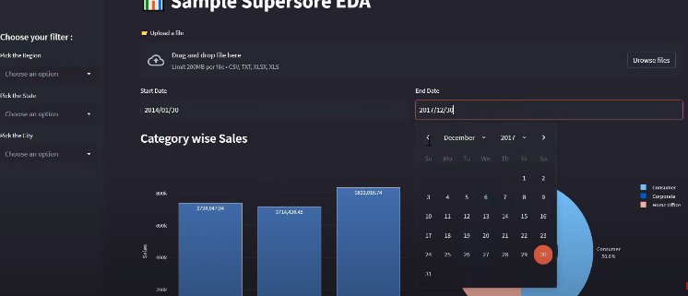

**Area filtering:**

Use a bendy search to personalize the search territory. This granular approach lets in users to focus on precise markets or geographies, gaining actionable insights in line with local context.

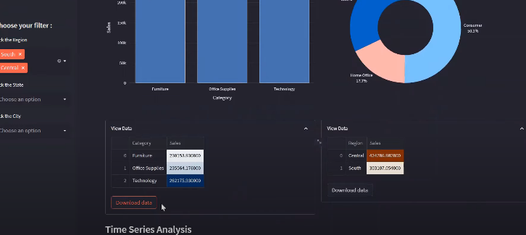

**Timeline alternatives:**

Define the power of income analysis timelines for every day, weekly, or month-to-month periods to a goal date. Time adjustment lets in users to conduct in-intensity evaluation of sales, seasonal adjustments, and historical overall performance.

**Graphing options:**

Turn uncooked sales records into complicated graphs with a lot of special layouts, together with bar charts, pie charts, and scatter plots These interactive charts offer insights which are active on income distribution, product development, and patron behavior.

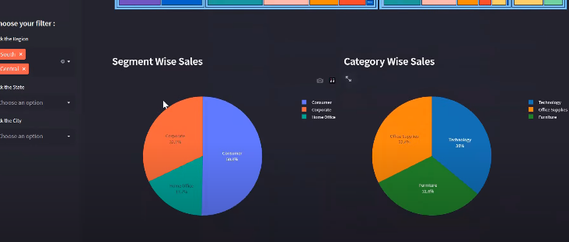

**Time Series Analysis:**

Unlock the potential of time series analysis to perceive underlying styles and developments in sales statistics through the years. Advanced statistical techniques and predictive fashions permit users to discover seasonal tendencies, forecast future sales, and optimize inventory control.

**Hierarchical Sales View:**

Provides a multi-degree view of income operations across product classes, subcategories, and segments, the use of tree map visualization thru hierarchical sales records This layout simplifies to perceive and examine the key drivers of sales.

**Data Download Functionality:**

Empower users to down load income statistics at once from the dashboard for in addition evaluation or for integration with external systems. Whether exporting uncooked facts for superior analytics or reporting to stakeholders, this selection will increase flexibility and statistics availability.

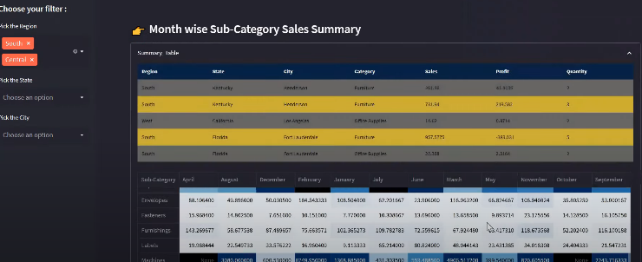

The Superstore Sales Analytics Dashboard is a flexible device designed to empower retail shops with insights they could use to pressure increase, improve efficiencies, and maximize income By harnessing the energy of statistics analytics businesses can remain competitive in now a days dynamic marketplace.

The Dashboard is an all-encompassing solution designed to empower retail businesses with actionable insights for driving growth, optimizing operations, and maximizing profitability. By seamlessly integrating advanced analytics and intuitive visualization tools, the dashboard facilitates comprehensive analysis of sales data across various dimensions such as geographical regions, time frames, and product categories. From identifying seasonal trends and forecasting future sales to optimizing inventory management and pricing strategies, every feature of the dashboard is meticulously crafted to meet the diverse needs of retail professionals.

In essence, the Superstore Sales Analysis Dashboard serves as a catalyst for data-driven decision-making, empowering retail businesses to stay ahead of the competition, adapt to changing market dynamics, and unlock new avenues for growth in today's rapidly evolving retail landscape.